How to Request a Change as a Bluestem Brands Inc, Vendor Partner
The purpose of this job aid is to explain the different types of changes you can request as a vendor doing business with Bluestem Brands Inc. as well as how to request those changes in our systems.
The following Change Requests are available:
Company Name change
Banking and Remittance Advice
Contact Changes or Additions or Deletions
To request a change, please follow the steps below:
- Login into our system at https://account.rollstream.com/accounts/login. If you do not have a login and password, please send an email to Supplier.Management@bluestembrands.com. Enter your Username and password and click GO.
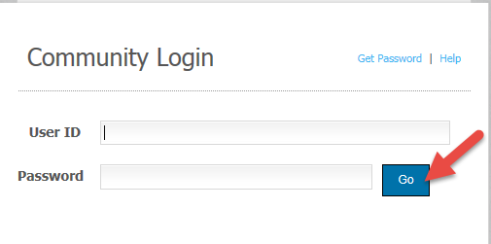
- Click on My Company link.
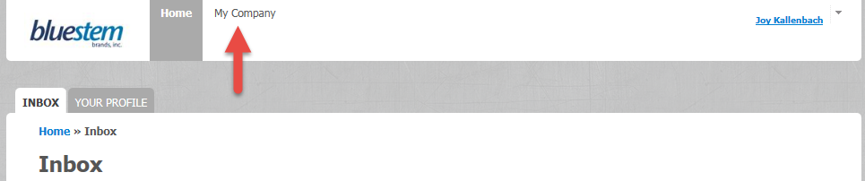

- Click on the Change Request tab on the left.
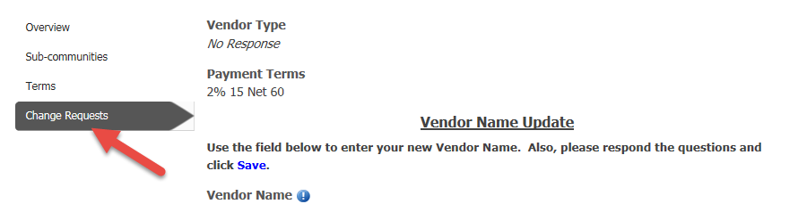

- Click on Manage Company link.
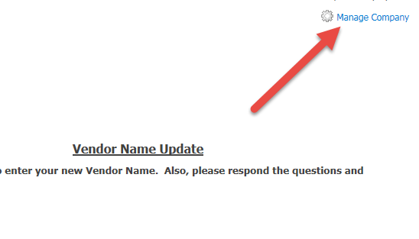
- Next click Edit Company from the dropdown.
- Answer Yes or No if you are making a Vendor Name Change today.
  - If you answer No proceed to step 9 below.
- If Yes change your Vendor name, go to the Vendor Name Update section, perform the following steps and click SAVE:
    - Enter new Company Name under Vendor Name Field.
    - If your Federal Tax ID number has changed you will need a new vendor number. Please contact your buyer.
    - Upload you latest W8/W9 form.
    - Upload Certificate of Insurance with the new name.

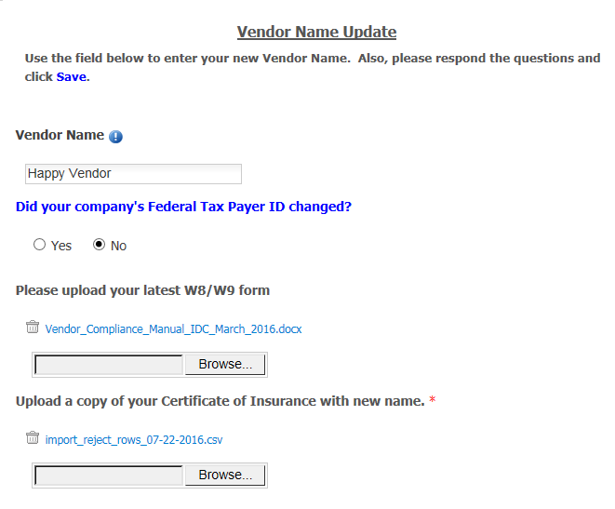
- Process will kick off internally once Save is selected.
To make a Remittance Address & Banking Information Update:
  - Follow steps 1 through 6 above.
  - Go to the Remittance Address & Banking Information Update section
- Click the Banking Information Update box.
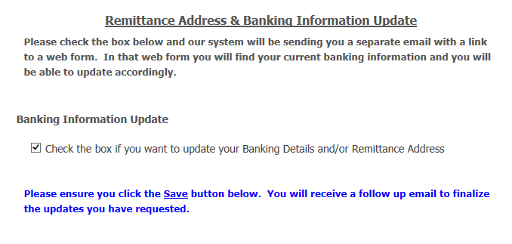
- You will receive an email shortly with further details and questions. Please fill out the form and submit back to us.

- Once the form is submitted back, our internal teams will begin making changes.

Add or update Contacts
If you need to change a contact in ACM, you will need to login to ACM as stated in step 1 above.
After logging in, click on the My Company link.

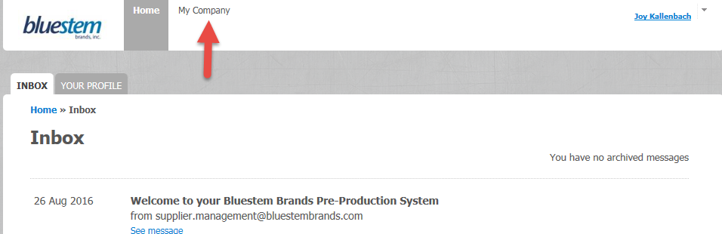
- Click on the Contacts tab.
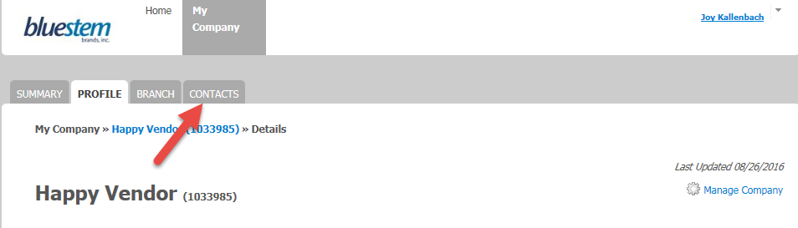

- If you just want to update contact information of an existing Contact, click on the name you want to edit.

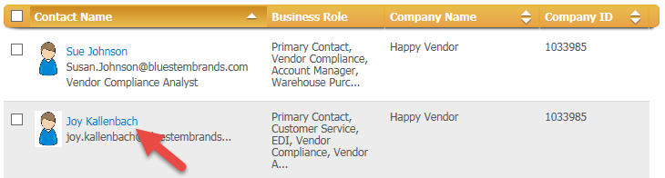
- Click on the Manage Contact link and select Edit Contact.
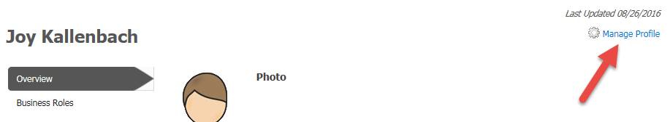
- You can edit any field or Business Role. Click Save.
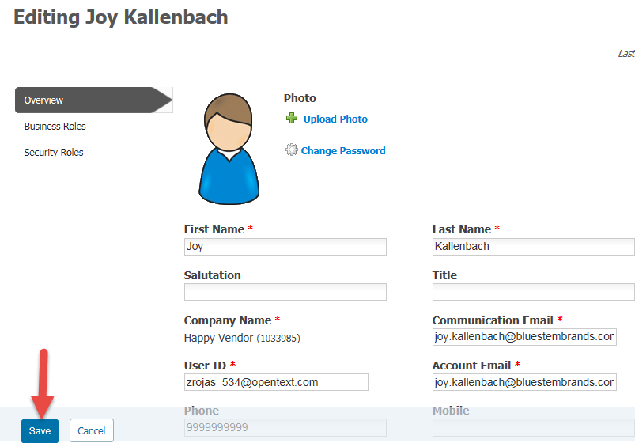
- If you want to CREATE a New contact. From the Contacts tab, click Manage Contacts link and select Add Contacts option.
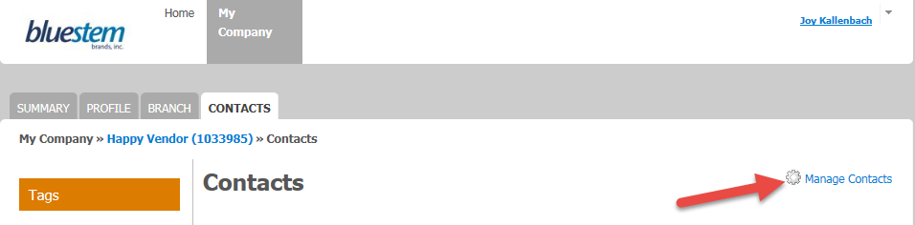
- Enter the mandatory fields of First Name, Last Name and Email address.
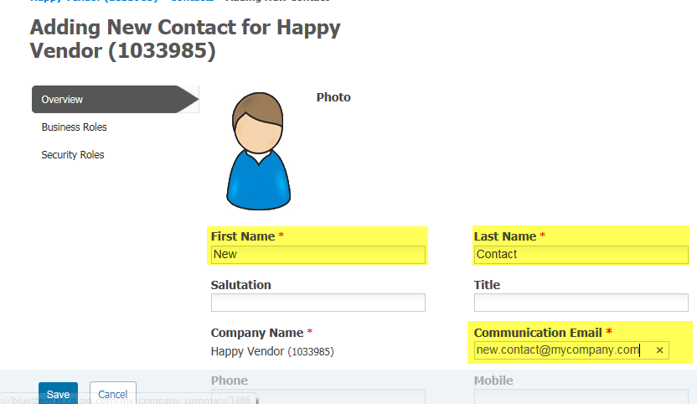
- Click on Business Roles link.

- Select the appropriate roles for this new contact. Click SAVE.
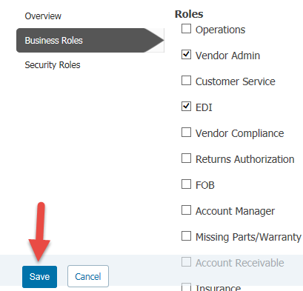
- If you want to delete a contact, click on the Manager Contacts link of the person you are trying to delete.

- From the dropdown select the DELETE Contact option.

- You will be prompted to verify you want to delete the contact. Click DELETE if you want to delete.

